

Structural Design

(Inside View)

**Vertical corrugation**

291*/*4

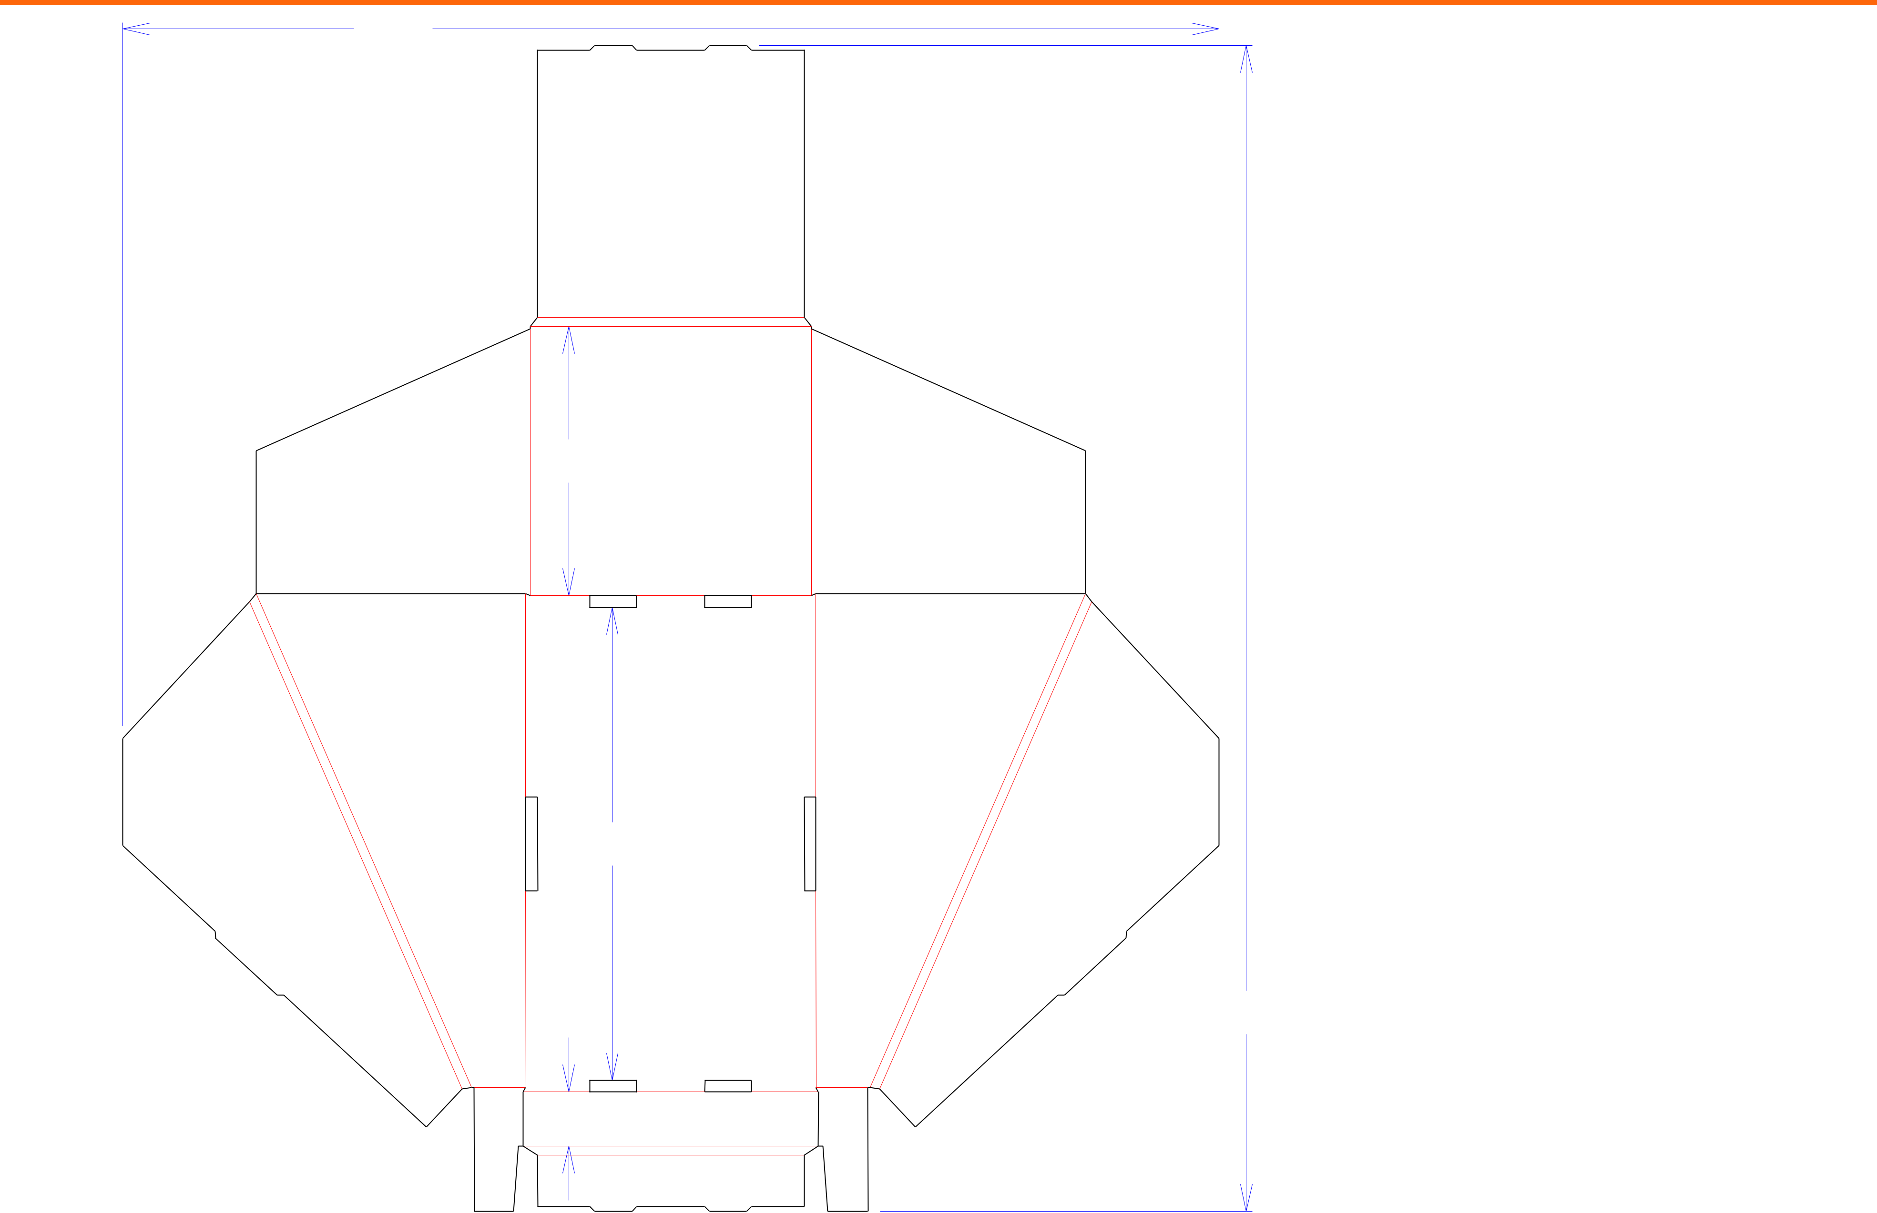

73*/*16

125*/*8

 71*/*8 

311*/*8

17*/*16

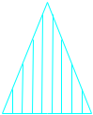

Cut Crease Crease with Matrix Cut Crease Half Knife Cut Tear Tape Perforation



Design#:

**191226-01**

Customer:

**DeMet's Candy**

Description:

**Holiday 2020 5.2 oz Assorted Gift Box DRC**

**SINGLE-OUT DRAWING**

Qty/Unit:

Style: **NJDC**

Board: **32BW**

Combination: **36MW - 23M - 35HP**

I.D. : **7+1/8 x 12+5/8 x 7+1/8**

Area of Blank - Waste : **3.78 sq. ft.**

Waste on Blank : **40.17%**

Finished Piece Weight: **0.40 lbs./179.68g**

Over-all Blank: **31+1/8 x 29+1/4**

Notes:

**Front lip: 1.375"; based on 160389-01_C**

Revision Info: **[0] 12/10/2019**

Designer: **Amy Kirchhoff**

Designright and Copyright of DS Smith Corrugated Packaging Ltd. This technical Specification is subject to Manufacturing tolerances. Drawing dimensions shown are crease to crease. Date printed: 12/10/2019